

Semester Two Examination, 2020

Question/Answer booklet

MATHEMATICS SPECIALIST
UNIT 1&2

Section Two:

Calculator-assumed

Your Name

Your Teacher’s Name

Time allowed for this section
Reading time before commencing work: ten minutes
Working time: one hundred minutes

Materials required/recommended for this section
To be provided by the supervisor
This Question/Answer booklet
Formula sheet (retained from Section One)

To be provided by the candidate
Standard items: pens (blue/black preferred), pencils (including coloured), sharpener, correction fluid/tape, eraser, ruler, highlighters

Special items: drawing instruments, templates, notes on two unfolded sheets of A4 paper, and up to three calculators approved for use in this examination

Important note to candidates
No other items may be taken into the examination room. It is your responsibility to ensure that you do not have any unauthorised material. If you have any unauthorised material with you, hand it to the supervisor before reading any further.

Question | Marks | Max | Question | Marks | Max
9 |  | 10 | 16 |  | 6
10 |  | 6 | 17 |  | 6
11 |  | 5 | 18 |  | 8
12 |  | 9 | 19 |  | 8
13 |  | 7 | 20 |  | 8
14 |  | 10 | 21 |  | 7
15 |  | 10

Structure of this paper

Section | Number of questions available | Number of questions to be answered | Working time (minutes) | Marks available | Percentage of examination
Section One:  Calculator-free | 8 | 8 | 50 | 54 | 36
Section Two:  Calculator-assumed | 13 | 13 | 100 | 100 | 64
 |  |  |  | Total | 100
Instructions to candidates

- The rules for the conduct of the Western Australian Certificate of Education ATAR course examinations are detailed in the Year 12 Information Handbook 2019. Sitting this examination implies that you agree to abide by these rules.

- Write your answers in this Question/Answer booklet.

- You must be careful to confine your answers to the specific questions asked and to follow any instructions that are specific to a particular question.

- Additional pages for the use of planning your answer to a question or continuing your answer to a question have been provided at the end of this Question/Answer booklet. If you use the space to continue an answer, indicate in the original answer space where the answer is continued, i.e. give the page number.

- Show all your working clearly. Your working should be in sufficient detail to allow your answers to be checked readily and for marks to be awarded for reasoning. Incorrect answers given without supporting reasoning cannot be allocated any marks. For any question or part question worth more than two marks, valid working or justification is required to receive full marks. If you repeat any question, ensure that you cancel the answer you do not wish to have marked.

- It is recommended that you do not use pencil, except in diagrams.

- The Formula sheet is not to be handed in with your Question/Answer booklet.

See Next Page
Section Two: Calculator-assumed (100 Marks)

This section has 13 (thirteen) questions. Answer all questions. Write your answers in the spaces provided.

Spare pages are included at the end of this booklet. They can be used for planning your responses and/or as additional space if required to continue an answer.
● Planning: If you use the spare pages for planning, indicate this clearly at the top of the page.
● Continuing an answer: If you need to use the space to continue an answer, indicate in the original answer space where the answer is continued, i.e. give the page number. Fill in the number of the question that you are continuing to answer at the top of the page.

Working time: 100 minutes.

Question 9 (2.2.1, 2.2.5-2.2.7, 2.2.9, 2.2.10) (10 marks)

Consider the triangle with vertices $A(0,0)$, $B(1,0)$ and $C(1,4)$, plotted below.

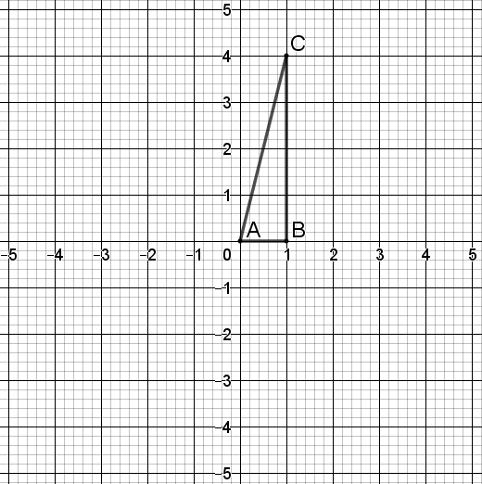

- The triangle is transformed by a matrix $M$ to give an image with vertices $A'(0,0)$, $B'(0,1)$ and $C'(-4,1)$. Write down the matrix $M$. (2 marks)
Solution
$M$ is a rotation by $\frac{π}{2}$, and so
$$M=\left[\begin{matrix}0 & -1 \\ 1 & 0\end{matrix}\right]$$

Specific behaviours
states transformation or sketches diagram
states correct matrix

Question 9 continued

- Triangle $A'B'C'$ (the image from part (a) ) is transformed by a matrix $N$ to give an image with vertices $A''(0,0)$, $B''(0,-1)$ and $C''(-4,-1)$. Write down the matrix $N$. (2 marks)
Solution
$N$ is a reflection through $y=0$, and so
$$N=\left[\begin{matrix}1 & 0 \\ 0 & -1\end{matrix}\right]$$

Specific behaviours
states transformation or sketches diagram
states correct matrix

- Hence write down the matrix $P$ which would transform triangle $ABC$ to triangle $A''B''C''$, showing your working. (3 marks)
Solution
$$P=NM \\ =\left[\begin{matrix}1 & 0 \\ 0 & -1\end{matrix}\right]\left[\begin{matrix}0 & -1 \\ 1 & 0\end{matrix}\right] \\ =\left[\begin{matrix}0 & -1 \\ -1 & 0\end{matrix}\right]$$

Specific behaviours
multiplies $N$ and $M$ (in either order)
multiplies in correct order
states correct matrix

- The triangle $ABC$ is transformed by a matrix $Q$ to a triangle with coordinates $A'''(0,0)$, $B'''(2,1)$ and $C'''(2,7)$. State the value of $\det{Q}$, given that $\det{Q}>0$, justifying your answer.
(3 marks)
(Solution
$ΔABC$ has area $\frac{1}{2}×1×4=2$ and $ΔA'''B'''C'''$ has area $\frac{1}{2}×6×2=6$.

Hence $\left|\det{Q}\right|=\frac{6}{2}=3$ and since $\det{Q}>0$, it follows that $\det{Q}=3$.
Specific behaviours
determines areas of$ΔABC$ and $ΔA'''B'''C'''$
divides $6$ by $2$
states $\det{Q}=3$

Question 10 (1.1.1, 1.1.2, 1.1.3, 1.1.4) (6 marks)

The genetic code is a set of rules defined by the four nucleotides of DNA, represented by the letters A, T, C and G. Three-letter nucleotide sequences are made from the four nucleotides.
- With no restrictions, how many 3-letter nucleotide sequences are possible in DNA?
(1 mark)

Solution
$$4×4×4=64$$

Specific Behaviours
correct number

- How many 3-letter nucleotide sequences start with A and end with C? (2 marks)

Solution
$$1×4×1=4$$

Specific Behaviours
uses multiplicative reasoning
correct number

- How many 3-letter nucleotide sequences have a G at least twice? (3 marks)

Solution
$$1+\left(\begin{matrix}3 \\ 1\end{matrix}\right)×3=10$$

Specific Behaviours
identify two cases
uses addition principle
correct number

Question 11 (2.3.7-2.311, 2.3.13-2.3.16) (5 marks)

Consider the following quadratic equation where $c$ is a real number.

$$x^{2}+12x+c=0$$

One of the solutions to this equation is $z=-6+3i$.

- Write down the other solution $w$ of the equation, and plot (and label) both solutions in the complex plane below. (3 marks)
Solution
$$w=\overline{z}=-6-3i$$

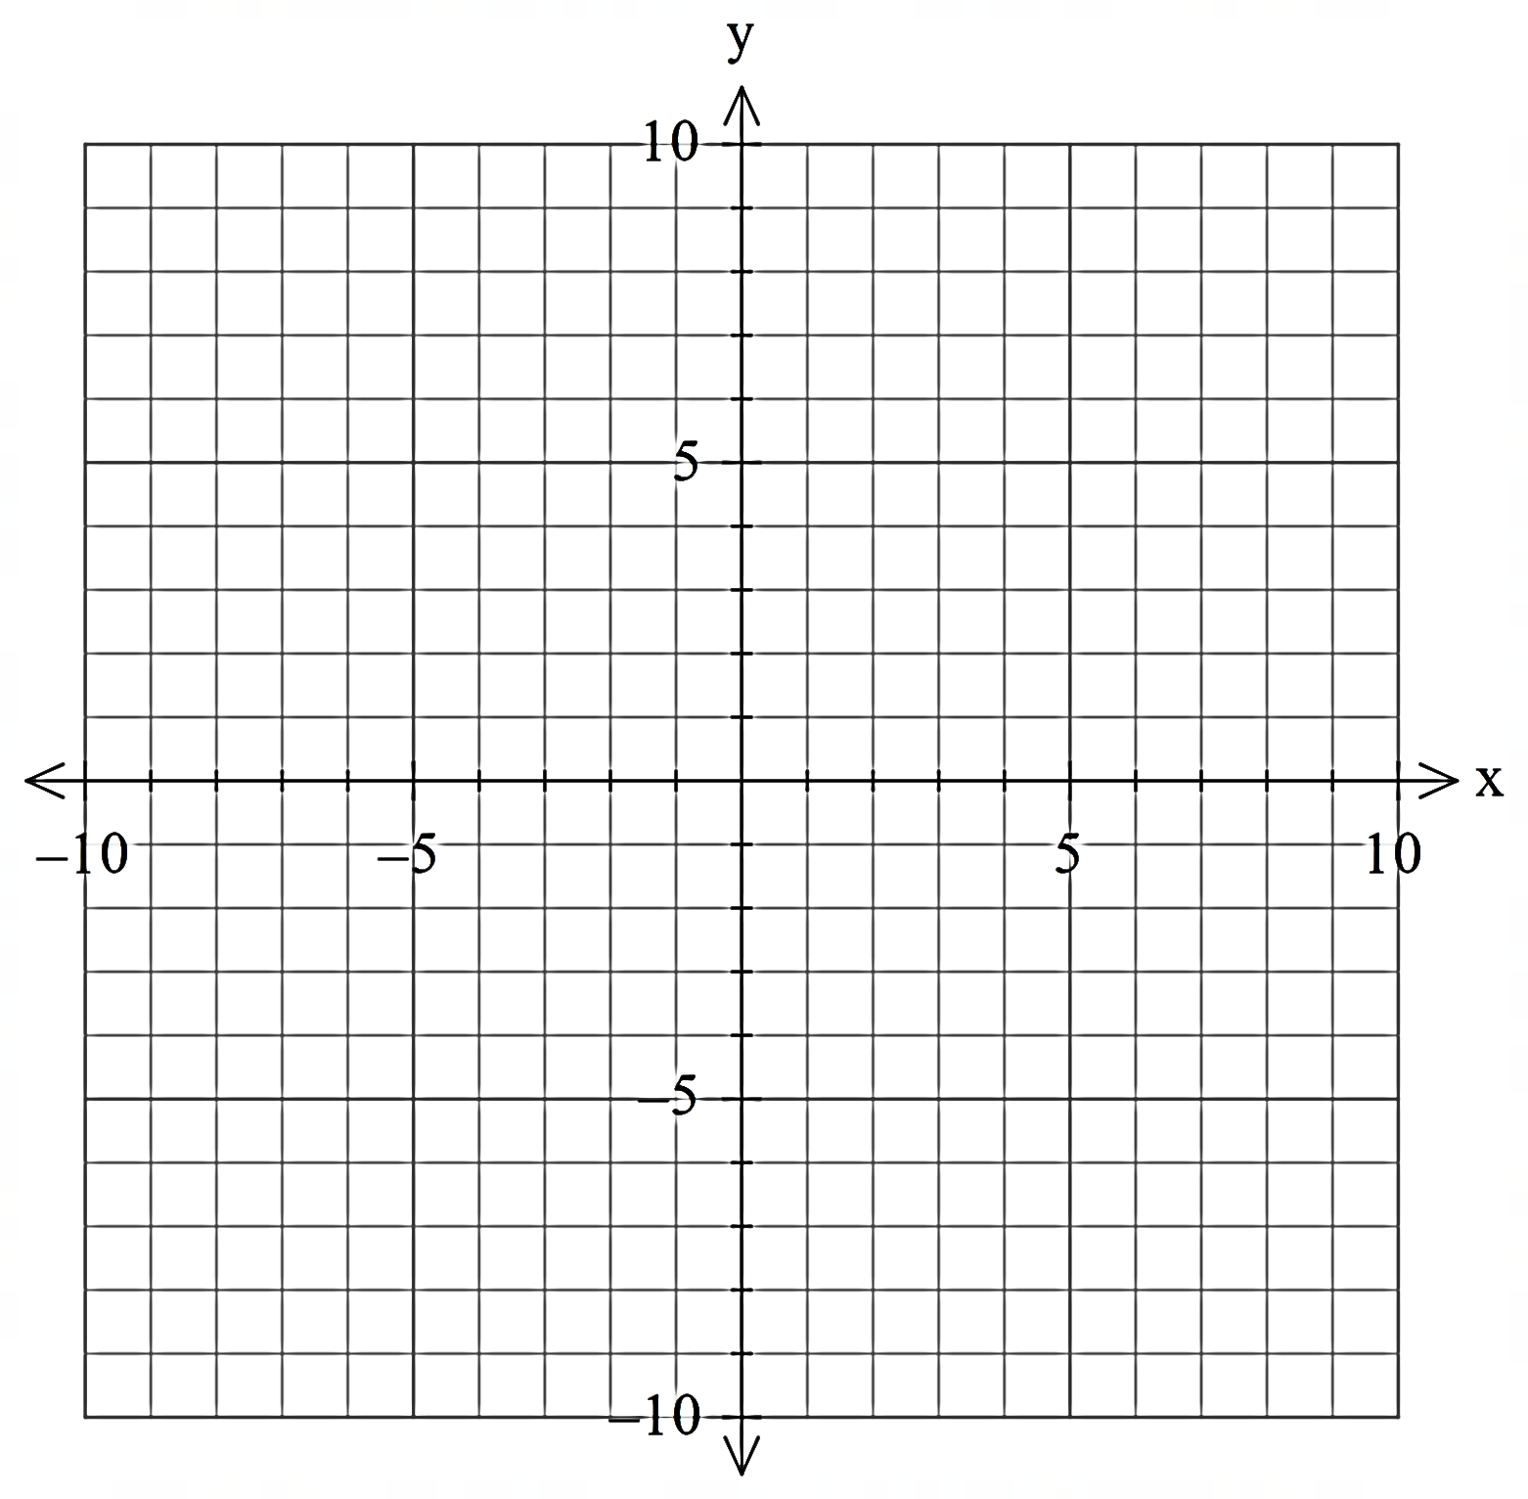
$$Re(z)$$
$$Im(z)$$

Specific behaviours
writes correct value for $w$
plots and labels $z$ in correct position
plots and labels $w$ in correct position

- Hence (or otherwise) determine the value of $c$. (2 marks)

Solution
$$c=z×w \\ =\left(-6+3i\right)\left(-6-3i\right) \\ =36+9 \\ =45$$

Specific behaviours
multiplies $z$ and $w$ states $c=45$

Question 12 (2.1.1-2.1.2, 2.1.9) (9 marks)

A roofing panel with the dimensions shown below has been left on the ground. An ant is walking across the top of the panel from the left end to the right end.

- Write a function in the form

$$h=a\cos{(b(x-c)})+d$$

modelling the height $h mm$ that the ant is above the ground in terms of the horizontal distance $x mm$ that the ant is from the left end of the panel. Specify the domain of the function. (Assume the panel has negligible thickness.) (3 marks)

- Graph the function on the axes below. (3 marks)
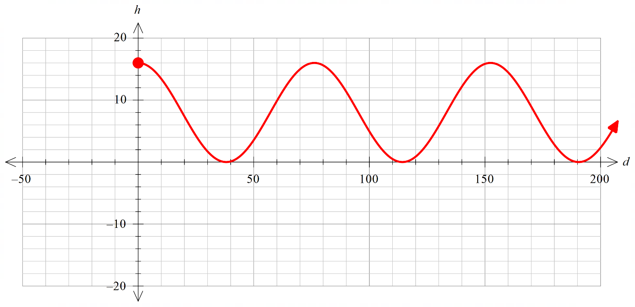
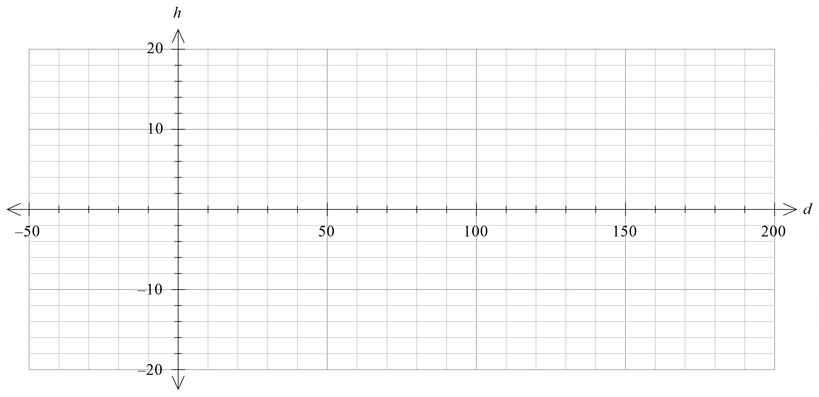

- The ant gets tired and stops to rest the third time he is climbing at a height of $12 mm$. How far (horizontally) does he have left to walk? (3 marks)

Question 13 (2.1.4) (7 marks)

- Describe the transformation of $y=\operatorname{cosec}\left(x\right)$ to $y=2\operatorname{cosec}\left(x\right)-4$. (2 marks)

- Sketch $y=2\operatorname{cosec}\left(x\right)-4$ on the graph shown, labelling all key features.
(5 marks)

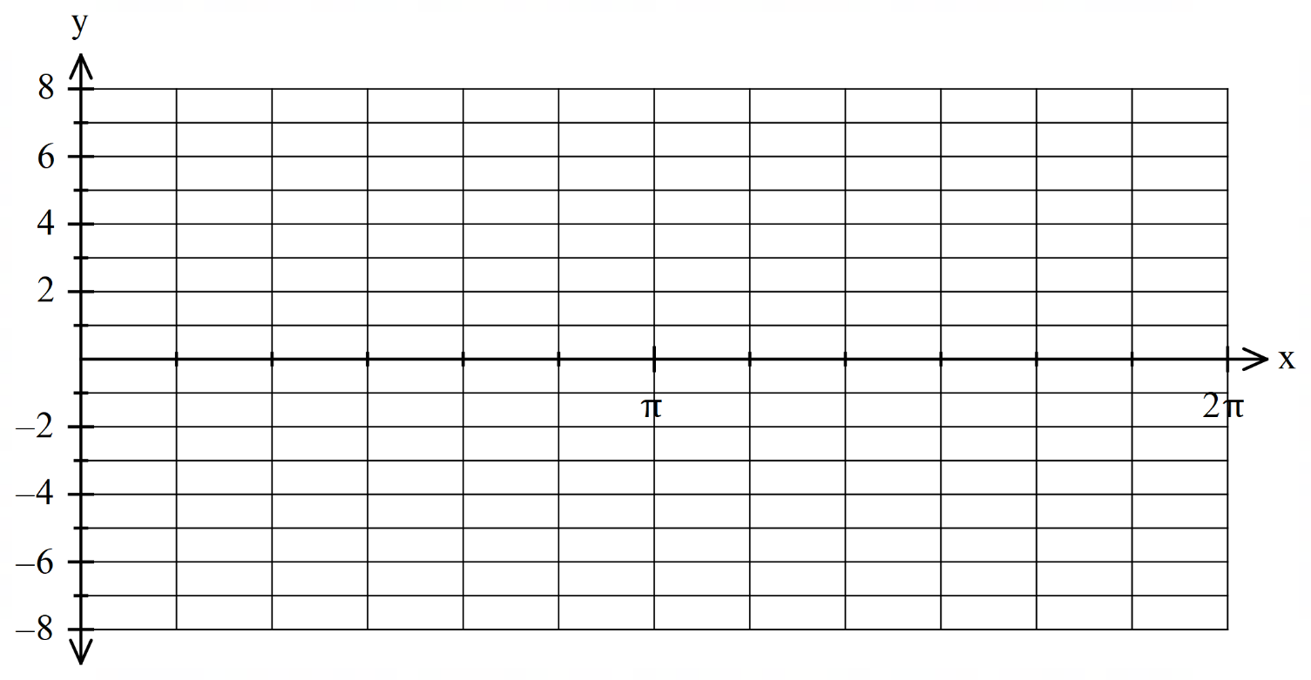
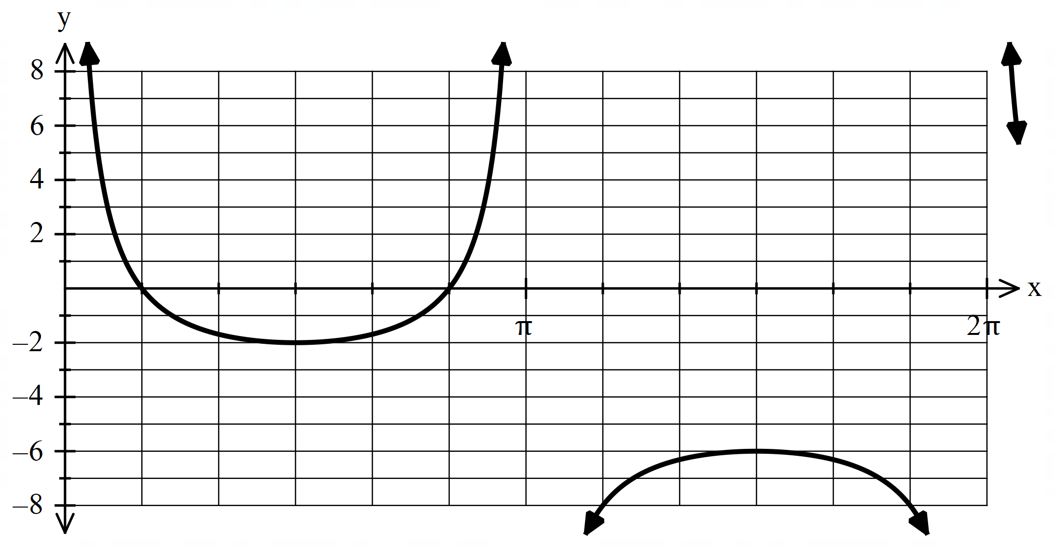

Question 14 (1.2.6-1.2.13) (10 marks)

- Three vectors are given by $a=5i-12j, b=-15i+10j$ and $c=-7i+yj$ where $y$ is a constant.
  - Determine the vector projection of $b$ on $a$ (give components as exact values).
(3 marks)
Solution
$$\hat{a}=\frac{1}{13}\left(5ⅈ-12j\right)$$

$$b⋅\hat{a}=-15$$

$$\left(b⋅\hat{a}\right)\hat{a}= \frac{-75}{13}ⅈ+\frac{180}{13}j$$
Specific behaviours
- States unit vector for $a$
- States $b⋅\hat{a}$
- States projection as a vector

  - Find $y$ if the angle between $b$ and $c$ is $45°$. (3 marks)
Solution  $$cos⁡(45)=\frac{\left(-15i+10j\right).(-7i+yj)}{|-15i+10j|.|-7i+yj|}$$  $y=35$or$y= -\frac{7}{5}$  Specific behaviours  - Uses scalar product  - States one solution  - States second solution | 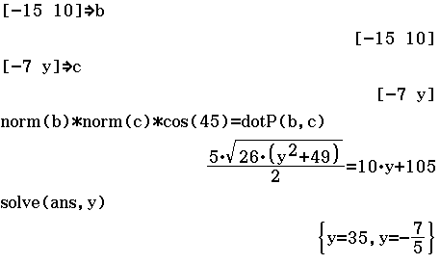
- Vectors $ai+\left(a-3\right)j$ and $(a-7)i+5j$ are perpendicular. Find the value(s) of $a$ and the corresponding pairs of vectors. (4 marks)
Solution
$$\left(\begin{aligned}a \\ a-3\end{aligned}\right)⋅\left(\begin{aligned}a-7 \\ 5\end{aligned}\right)=a^{2}-2a-15=0$$

$$\left(a+3\right)\left(a-5\right)=0$$

$a=-3$ or $a=5$
$if a=-3$, the vectors are $-3i-6j$ and $-10i+5j$
$if a=5$, the vectors are$5+2j$ and $-2i+5j$

Specific behaviours
- Uses (dot product = 0) to form quadratic equation
- Solves for two values of $a$
- States one pair of vectors
- States two pairs of vectors

Question 15 (1.3.6-1.3.15) (10 marks)

- Consider the diagram below. $\overline{AD}$ and $\overline{BE}$ are diameters of the circle with centre $O$, $∠COD= 32°$ and $C$ lies on the circumference of the circle such that $AB=BC$.
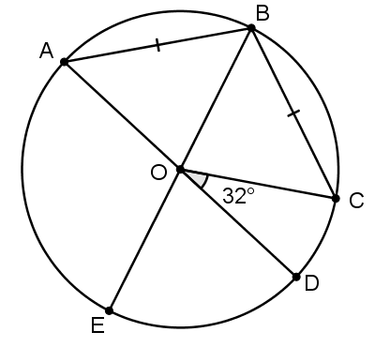
Determine the sizes of the following angles
- $∠AOB$ (2 marks)
Solution
$$∠AOB=∠BOC$$
$∠AOB+∠BOC+32 =180$
$$∠AOB=\frac{180-32}{2}$$
$$∠AOB=74°$$
Specific behaviours
- Uses congruent angles
- Calculates angle

- $∠CAE$ (3 marks)
Solution
$$∠DOE=∠AOB=74°$$
$$∠COE=74+32=106°$$
$$∠CAE=\frac{106°}{2}$$
$$=53°$$
Specific behaviours
- Indicates size of $∠DOE$
- Uses relationship between angle at centre and at circumference
- Calculates angle

- In the diagram below, $W$ is the single point of intersection of the two circles. The segment $\overline{XY}$ is tangent to both circles, intersecting with the circles at $X$ and $Y$. Segment $\overline{WZ}$ is also tangent to both circles, intersecting with $\overline{XY}$ at $Z$. Prove that $ΔXWY$ is a right triangle. (5 marks)

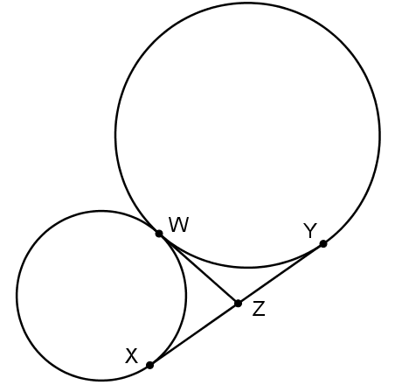

Solution
$ZX=ZW$ and $ZW=ZY$ (tangents from a common point)
Hence $X$, $W$ and $Y$ lie on a circle with centre $Z$.
$\overline{XY}$ is a diameter of this circle and so $∠XWY$ is an angle in a semicircle.
Hence $∠XWY=90°$.
It follows that $ΔXWY$ is a right triangle.
Specific behaviours
- Notes that $XY=ZW=ZY$
- Gives reason for above
- States that $X$, $W$ and $Y$ lie on a circle with centre $Z$
- States that $∠XWY$ is an angle in a semicircle
- Concludes that $∠XWY=90°$

Question 16 (1.2.2, 1.2.8, 1.2.14) (6 marks)

Three forces act on the point $A$ as shown. What is the magnitude of the resultant force acting on $A$, and in what direction would $A$ move under these three forces?
Give your answers to 2 decimal places, with the direction as an angle measured anticlockwise from the right (like the $30°$ angle for Force 1).
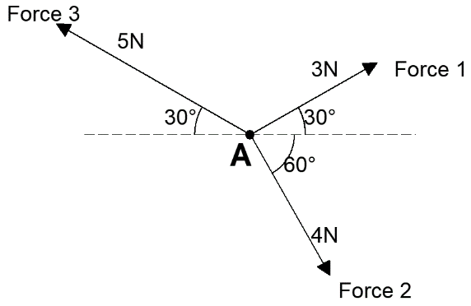

Solution
Force 1 $=3\cos{30}i+3\sin{30}j$
Force 2 $=4\cos{60}i-4\sin{60}j$
Force 3 $=-5\cos{30}i+5\sin{30}j$

Resultant force:
$$F=\left(\frac{3\sqrt{3}}{2}+\frac{4}{2}-\frac{5\sqrt{3}}{2}\right)i+\left(\frac{3}{2}-\frac{4\sqrt{3}}{2}+\frac{5}{2}\right)j \\ =\left(2-\sqrt{3}\right)i+\left(4-2\sqrt{3}\right)j$$

Magnitude of force:
$$\left|F\right|=\sqrt{{\left(2-\sqrt{3}\right)}^{2}+{\left(4-2\sqrt{3}\right)}^{2}} \\ ≈0.60 N$$

Direction of force:
$$\tan^{-1}\left(\frac{4-2\sqrt{3}}{2-\sqrt{3}}\right)≈63.43°$$

Therefore the direction is $63.43°$

Specific behaviours
writes correct vector expression for at least one force (accept expressions using polar angles e.g. Force 2 $=4\cos{300}i+4\sin{300}j$)
writes correct vector expressions for at least two forces
writes correct vector expressions for all three forces
determines vector expression for resultant force
states correct magnitude of resultant force
state correct direction of resultant force

Question 17 (2.2.1, 2.2.2) (6 marks)

- Given invertible $n×n$ matrices $A$, $B$, $C$ and $X$ with $AX-B=CBX$, write $X$ in terms of $A$, $B$ and $C$.
(3 marks)
Solution
$$AX-B=CBX \\ AX-CBX=B \\ \left(A-CB\right)X=B \\ X={\left(A-CB\right)}^{-1}B$$
Specific behaviours
collects terms with $X$ on LHS
factorises $X$ out on the right
multiplies both sides by ${\left(A-CB\right)}^{-1}$

- Solve the following matrix equation for $Y$
$$3Y-Y\left[\begin{matrix}1 & -3 \\ 1 & 6\end{matrix}\right]=5I$$
(3 marks)

Solution
$$3Y-Y\left[\begin{matrix}1 & -3 \\ 1 & 6\end{matrix}\right]=5I$$
$$Y\left(3I-\left[\begin{matrix}1 & -3 \\ 1 & 6\end{matrix}\right]\right)=5I \\ Y\left[\begin{matrix}2 & 3 \\ -1 & -3\end{matrix}\right]=5I \\ Y=5I{\left[\begin{matrix}2 & 3 \\ -1 & -3\end{matrix}\right]}^{-1} \\ =\frac{5}{3}\left[\begin{matrix}3 & 3 \\ -1 & -2\end{matrix}\right]$$
Specific behaviours
factorises $Y$ out on the left
evaluates $3I-\left[\begin{matrix}1 & -3 \\ 1 & 6\end{matrix}\right]$
multiplies both sides by ${\left[\begin{matrix}2 & 3 \\ -1 & -3\end{matrix}\right]}^{-1}$ and obtains correct answer

Question 18 (1.1.7, 1.1.8) (8 marks)

Four Year 10 students and eleven Year 11 students from Western Australia are nominated as candidates for a Mathematics Summer Camp. How many ways can a group of four participants be selected:
- without restriction? (2 marks)

Solution
$$\left(\begin{matrix}15 \\ 4\end{matrix}\right)=1365$$

Specific Behaviours
correct expression
correct number

- if the only student from Bunbury must be included? (2 marks)

Solution
$$\left(\begin{matrix}1 \\ 1\end{matrix}\right)\left(\begin{matrix}14 \\ 3\end{matrix}\right)=364$$

Specific Behaviours
correct expression
correct number

- if there must be exactly two Year 11 students? (2 marks)

Solution
$$\left(\begin{matrix}11 \\ 2\end{matrix}\right)\left(\begin{matrix}4 \\ 2\end{matrix}\right)=330$$

Specific Behaviours
correct expression
correct number

- if there must be at least one Year 10 student? (2 marks)

Solution
$$\left(\begin{matrix}15 \\ 4\end{matrix}\right)-\left(\begin{matrix}11 \\ 4\end{matrix}\right)=1035$$

Specific Behaviours
correct expression
correct number

Question 19 (1.1.5, 1.1.9) (8 marks)

- How many integers between 1 and 101 are multiples of 5, 6 or 7? (4 marks)

Solution
Multiples of $5: 100÷5=20$
Multiples of $6: 100÷6=16$ (rounded down)
Multiples of $7: 100÷7=14$
Multiples of $30 (5$and$6): 100÷30=3$
Multiples of $35 (5$and$7): 100÷35=2$
Multiples of $42 (6$and$7): 100÷42=2$
Multiples of $210 (5, 6$and$7): 0$
Multiples of $5, 6,$or$7: 20+16+14-3-2-2+0=43$

Specific Behaviours
finds multiples of 5, 6, 7 respectively
finds multiples of 30, 35, 42 respectively
uses inclusion-exclusion principle
correct number

- Use the fact that ${}_{}^{n}{C_{r}=\frac{n!}{\left(n-r\right)!r!}}$ to show that ${}_{}^{n-1}{C_{r-1}×n}={}_{}^{n}{C_{r}×r}$. (4 marks)

Solution
$$LHS=\frac{(n-1)!}{[n-1-(r-1)]!(r-1)!}×n$$
$$=\frac{(n-1)!×n}{(n-r)!(r-1)!}$$
$$=\frac{n!}{(n-r)!(r-1)!}$$
$$=\frac{n!r}{(n-r)!r(r-1)!}$$
$$=\frac{n!}{(n-r)!r!}×r$$
$$={}_{}^{n}{C_{r}×r}$$
$$=RHS$$

Specific Behaviours
uses ${}_{}^{n}{C_{r}=\frac{n!}{\left(n-r\right)!r!}}$
writes $n(n-1)! as n!$
multiplies by $\frac{r}{r}$
writes $r(r-1)! as r!$

Question 20 (2.2.1-2.2.10) (8 marks)

Let $A=\left[\begin{matrix}\cos{α} & -\sin{α} \\ \sin{α} & \cos{α}\end{matrix}\right]$.

- Calculate $A^{2}$ (that is, $A×A$). Show working and simplify your answer. (3 marks)

Solution
$$A^{2}=\left[\begin{matrix}\cos{α} & -\sin{α} \\ \sin{α} & \cos{α}\end{matrix}\right]\left[\begin{matrix}\cos{α} & -\sin{α} \\ \sin{α} & \cos{α}\end{matrix}\right] \\ =\left[\begin{matrix}\cos^{2}{α}-\sin^{2}{α} & -\cos{α}\sin{α}-\cos{α}\sin{α} \\ \cos{α}\sin{α}+\cos{α}\sin{α} & -\sin^{2}{α}+\cos^{2}{α}\end{matrix}\right] \\ =\left[\begin{matrix}\cos{2α} & -\sin{2α} \\ \sin{2α} & \cos{2α}\end{matrix}\right]$$
Specific behaviours
writes unsimplified product (2nd line) with at least 2 entries correct
writes unsimplified product (2nd line) with all entries correct
simplifies using double angle formulas

- Calculate the product $A^{3}$ by multiplying your answer to part (a) by $A$ (you do not need to simplify your answer). (2 marks)

Solution
$$A^{3}=\left[\begin{matrix}\cos{2α} & -\sin{2α} \\ \sin{2α} & \cos{2α}\end{matrix}\right]\left[\begin{matrix}\cos{α} & -\sin{α} \\ \sin{α} & \cos{α}\end{matrix}\right] \\ =\left[\begin{matrix}\cos{2α}\cos{α}-\sin{2α}\sin{α} & -\cos{2α}\sin{α}-\sin{2α}\cos{α} \\ \sin{2α}\cos{α}+\cos{2α}\sin{α} & -\sin{2α}\sin{α}+\cos{2α}\cos{α}\end{matrix}\right]$$
Specific behaviours
at least 2 entries correct in product
all entries correct in product

- Determine a value of $α$ (with $0<α<2π$) such that $A^{3}=I$. Justify your answer by referring to the linear transformation corresponding to the matrix $A$. (3 marks)

Solution
If $α=\frac{2π}{3}$ then $A^{3}=I$.
Since $A$ represents a rotation by $α$, $A^{3}$ represents 3 rotations by $α$ applied in sequence; that is, $A^{3}$ is a rotation by $3α$. Thus if $α=\frac{2π}{3}$, $A^{3}$ is a rotation by $2π$, which is equivalent to a rotation by $0$, and therefore $A^{3}=I$.
Specific behaviours
states $α=\frac{2π}{3}$
notes that $A$ represents a rotation by $α$
notes that $A^{3}$ is 3 rotations by $α$, or a single rotation by $3α$

Question 21 (1.2.2, 1.2.3, 1.2.7, 1.2.9, 1.2.14) (7 marks)
An octopus, which can swim with a steady speed of 3.5 m/s through still water, leaves its home at $O$ to visit a sea anemone at $S$.
The position vector of $S$ relative to $O$ is $165i-212j$ m, and a current with velocity $-2.3i+1.1j$ m/s is flowing.
- Find the velocity vector $v$, in the form $ai+bj$, that the octopus should aim to swim with in order to reach the sea anemone in the shortest possible time. (Give $a$ and $b$ to 2 decimal places.) (5 marks)
Solution
We require
$$ai+bj+\left(-2.3i+1.1j\right)=λ\left(165i-212j\right)$$
so
$$a-2.3=165λ$$
$$b+1.1= -212λ$$
We also know that
$$a^{2}+b^{2}={3.5}^{2}$$

Solving these three equations simultaneously and taking the solution with $λ>0$ gives
$$v=2.93i-1.91j$$

Specific behaviours
equates sum of $v$and current velocity to a scalar multiple of displacement vector
equates components to get 2 linear equations
states equation $a^{2}+b^{2}={3.5}^{2}$
states at least one of $v=2.93i-1.91j$ and $v=-1.13i+3.31j$
states $v=2.93i-1.91j$ (i.e. solution corresponding to positive value of $λ$)

- Determine the time taken (to the nearest second) for the octopus to reach the sea anemone if it aims to swim with the velocity found in part (a). (2 marks)
Solution
EITHER
$λ=3.8×{10}^{-3}$ (from part (a))
Hence total time will be $\frac{1}{λ}=261 s$

OR
Horizontal component of resultant velocity $= 2.93-2.3=0.63$
$\frac{165}{0.63}= 262$ s

OR
$$\left|v+\left(-2.3i+1.1j\right)\right|=1.0262 \\ \left|165i-212j\right|=268.6429$$
Total time $=\frac{268.6429}{1.0262}=262$s

Specific behaviours
shows appropriate calculation
states 261 s or 262 s

END OF QUESTIONS

Additional working space
Question number:

Additional working space
Question number:

Additional working space
Question number:

